Kenai Brown Bear Paint Night
Featuring local artist Kari Becker
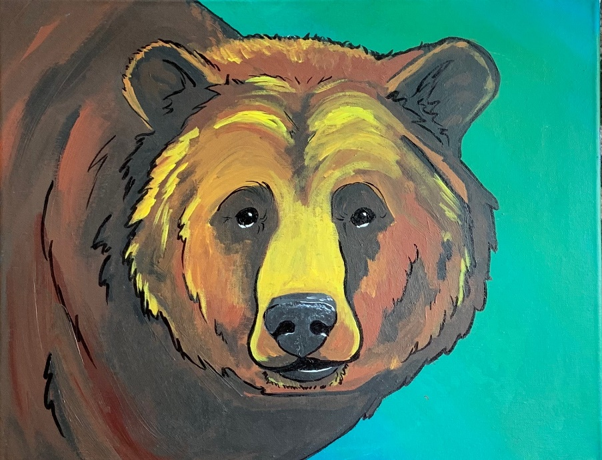
Supply List
- Suggested canvas size 16x20
- Paint: yellow, brown, black, white, turquoise, and green
- Chalk and large pencil sharpener
- Ruler
- Bucket of water
- Washcloth or paper towels to dry off brushes
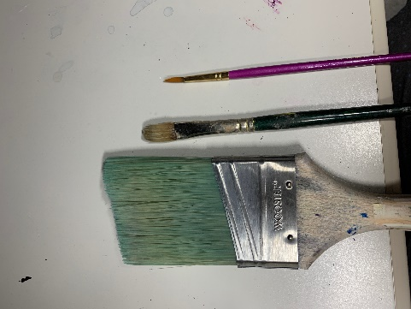
- Suggested brushes:
  - 2 inch paint brush
  - #6 flat paint brush
  - Line brush
  - Or XL, L, M, S brush sizes – having a selection is helpful, large brushes for painting background and small brushes for fine details
- Paint pen black or black sharpie (optional)

This paint night is meant for anyone who loves wildlife, specifically Kenai brown bears! Any skill level can join. Come and learn about Kenai brown bears while learning how to paint these majestic bears.

