Paint a Polar Bear
Featuring local artist Kari Becker
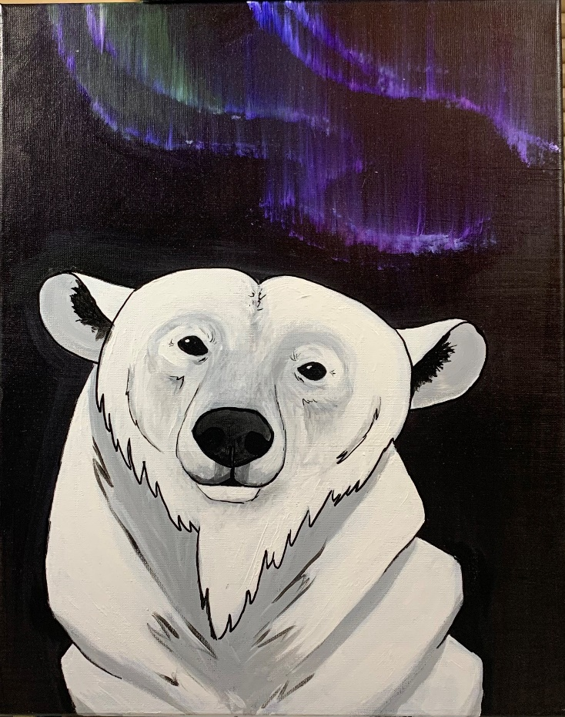
Supply List
- 16x20 canvas: please pre-paint your canvas black or buy a black canvas
- Paints needed: Black, white, dark blue, dark green, dark purple
- Large Fan brush or large fluffy old brush
- Large, medium and small brushes
- Paint pen, or sharpie
- Blow dryer
- Water container
- Chalk (sharpener if you have it) you won’t be able to see the layout drawing with pencil this time.
- Hand towel
- Paint pallet

This paint night is meant for anyone who loves wildlife, specifically polar bears! Any skill level can join. Come and learn about polar bears while learning how to paint these majestic bears.

